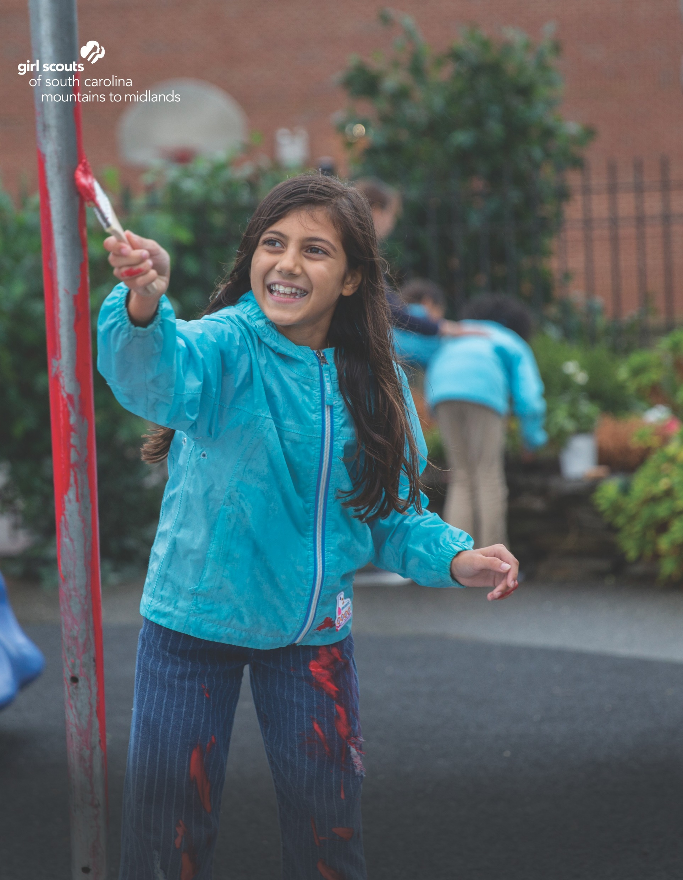
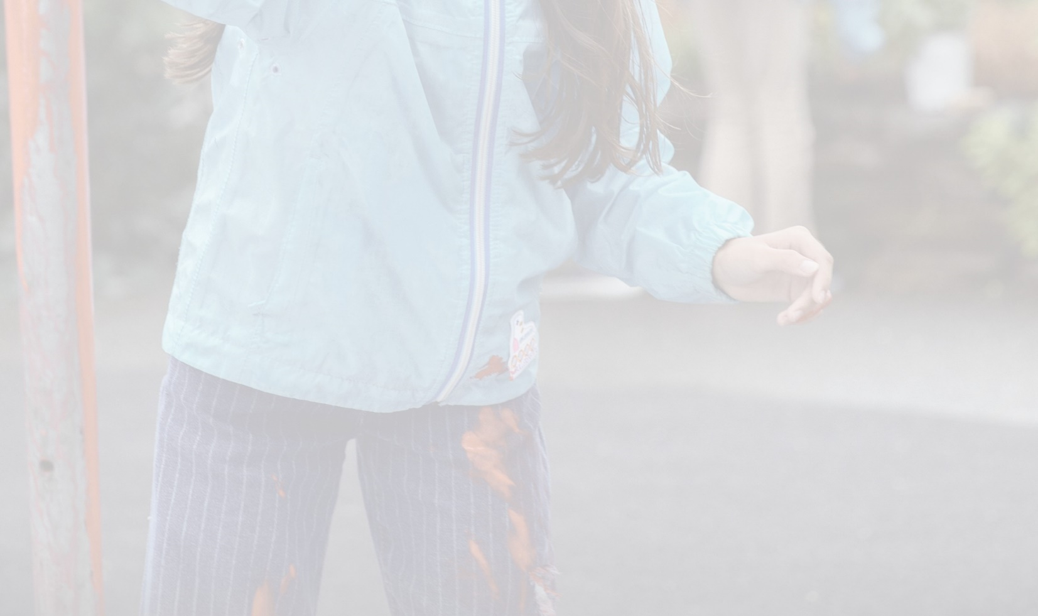

THERE IS POWER
IN EVERY
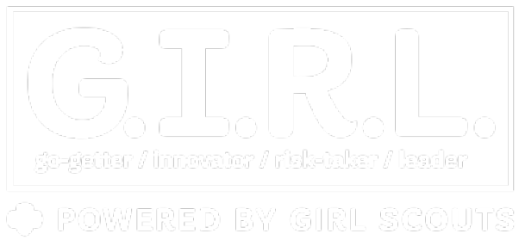
Unleash strong!
Be a Girl Scout.

At Girl Scouts we are always counting down to the next adventure. We prepare girls to be Go-getters, Innovators, Risk-takers, and Leaders. We prepare girls to empower themselves. With us, you will help her become the leader she was meant to be. So what are you waiting for?

Start the fun now!
Gssc-mm.org

Keep the fun going!
www.facebook.com/GSSCMM

This is a header! (At Size 18)
This is where you will put your event information and contact information. The space is tight, so try to keep your main copy at size 12.
Remember, this is a template! Use “SAVE AS” instead of “SAVE.”

This is a header! (At Size 18)
This is where you will put your event information and contact information. The space is tight, so try to keep your main copy at size 12.
Remember, this is a template! Use “SAVE AS” instead of “SAVE.”

Believe in the Power of G.I.R.L.
Join now at www.gssc-mm.org.

You can be a part of it, too! Volunteer today at www.gssc-mm.org.

